
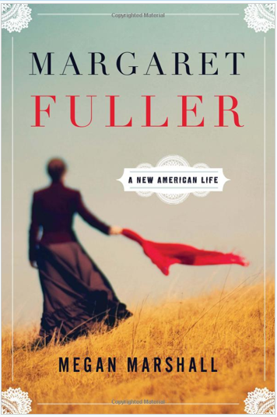
Please join me for a very special event. Megan Marshall will speak and sign copies of her new biography, Margaret Fuller.
Sunday July 7, 2013 2:00PM
Stanley Whitman House
37 High Street
Farmington, CT 06032
Megan Marshall the award-winning author of The Peabody Sisters takes a fresh look at the trailblazing life of a great American heroine—Thoreau’s first editor, Emerson’s close friend, first female war correspondent, and passionate advocate of personal liberation and political freedom.
From an early age, Margaret Fuller provoked and dazzled New England’s intellectual elite. Her famous Conversations changed women’s sense of how they could think and live; her editorship of the Transcendentalist literary journal The Dial shaped American Romanticism. Now, Megan Marshall, whose acclaimed The Peabody Sisters “discovered” three fascinating women, has done it again: no biography of Fuller has made her ideas so alive or her life so moving.
Marshall tells the story of how Fuller, tired of Boston, accepted Horace Greeley’s offer to be the New York Tribune’s front-page columnist. The move unleashed a crusading concern for the urban poor and the plight of prostitutes, and a late-in-life hunger for passionate experience. In Italy as a foreign correspondent, Fuller took a secret lover, a young officer in the Roman Guard; she wrote dispatches on the brutal 1849 Siege of Rome; and she gave birth to a son.
Yet, when all three died in a shipwreck off Fire Island shortly after Fuller’s 40th birthday, the sense and passion of her life’s work were eclipsed by tragedy and scandal. Marshall’s inspired account brings an American heroine back to indelible life.

PRAISE
“Margaret Fuller is as seductive as it is impressive. It has the grain and emotional amplitude of a serious novel . . . [and] pushes Ms. Marshall into the front rank of American biographers.”
—Dwight Garner, New York Times
“This month Megan Marshall joins the cohort of distinguished Fullerites with ‘Margaret Fuller: A New American Life.’ Marshall is a gifted storyteller steeped in the parochial society of nineteenth century-century Boston and Concord . . . There are many ways of doing justice to Fuller, and Marshall makes an eloquent case for her as a new paradigm: the single career woman, at home in a world of men, who admire her intelligence, though it turns them off; and the seeker of experience, who doesn’t want to miss out on motherhood, yet is terrified that it will compromise her work life . . . Marshall excels at creating a sense of intimacy—with both her subjects and her reader.”
— Judith Thurman, The New Yorker
“In this thoroughly absorbing, lively new biography, Megan Marshall’s sympathy for Fuller — for the dilemma she faced as a powerfully intelligent woman whose time and place repeatedly thwarted her ambitions — nearly outpaces her admiration, though the book passionately evokes both. Fuller, so often misunderstood in life, richly deserves the nuanced, compassionate portrait Marshall paints.”
—The Boston Globe

